Industrial Management
(IM41081)

Sales Acceleration using Digital Twin

Name : Adireddi Geethika
Roll No : 24EC10056

Objective :
- Build a faithful virtual replica of an e-commerce sales pipeline.
- Simulate multiple sales acceleration strategies as distinct scenarios.
- Measure KPI impact: revenue, conversion rate, average order value, and margin.
- Visualise results in an actionable dashboard for decision-makers.
Executive Summary :
This report presents the design, implementation, and results of a Sales Acceleration Digital Twin built for an E-Commerce / Retail business. A Digital Twin is a virtual, real-time replica of a physical or business system that allows organisations to simulate, predict, and optimise operations without disrupting live processes.
The simulation models 90 days of sales operations across 6 product categories and 4 customer segments. Three strategic scenarios were executed and compared:
- Baseline — normal operations with no intervention.
- Flash Sale — 20% discount coupled with a 40% traffic boost via marketing campaigns.
- Premium Push — a targeted 5% discount with loyalty-focused segment activation.
Key finding: The Flash Sale scenario generated the highest total revenue ($732,596), a 49% uplift over the Baseline ($490,073), while the Premium Push achieved a balanced improvement of $564,097 with higher margins per unit.
Introduction :
Background :
Modern e-commerce retailers face intense competition and rapidly shifting consumer behaviour. Traditional sales planning methods relying on historical reports are reactive — they reveal what happened, not what could happen. Digital Twins bridge this gap by enabling proactive, simulation-driven decision making.

Problem Statement :
E-commerce sales are influenced by dozens of interdependent variables: seasonal traffic patterns, customer segment behaviours, pricing elasticity, inventory constraints, and promotional campaigns. Testing strategies in a live environment carries high financial risk. A Digital Twin provides a risk-free sandbox to experiment with these variables.
Methodology & System Architecture
Digital Twin Architecture
The Digital Twin is implemented in Python and consists of five interconnected layers:
- Data Layer — Product catalogue, customer segment profiles, pricing, and inventory.
- Behaviour Models — Statistical models for visitor traffic, conversion rates, and basket sizes calibrated to real-world e-commerce benchmarks.
- Simulation Engine — A day-by-day event loop that advances the state of the twin across the simulation horizon.
- Scenario Injector — Parameterised overrides (discount rate, traffic multiplier, restock threshold) that alter twin behaviour without modifying core logic.
- Analytics & Dashboard — Aggregated KPIs exported as CSV files and visualised as a multi-panel Matplotlib dashboard.

Traffic & Conversion Modelling
Daily visitor traffic incorporates: (a) a weekly sinusoidal seasonality pattern reflecting weekend spikes, (b) an organic growth trend of 0.3% per day compounding, and (c) Gaussian noise to simulate real-world variability. Conversion rate is a function of customer segment loyalty, price sensitivity amplified by the current discount level, and real-time inventory availability.

Scenario Design :
Baseline Scenario
The Baseline represents normal store operations with no promotional intervention. It serves as the control benchmark against which all accelerated scenarios are measured. Standard pricing, organic traffic, and regular restock policies apply.

Flash Sale Scenario
A time-limited 20% discount is applied across all products, combined with a 40% uplift in daily visitors simulating the effect of a paid media campaign (email blast, social ads, PPC). Restock threshold is increased to 80 units to anticipate higher demand. This scenario tests revenue maximisation at the cost of margin.

Premium Push Scenario
A conservative 5% discount targets loyalty-sensitive and premium segments. Traffic is boosted by 10% through organic channels (SEO, loyalty newsletters). This scenario tests margin-preserving acceleration by focusing on high-value customer cohorts.

Simulation Results :

Revenue Analysis
The Flash Sale scenario produced the largest absolute revenue gain ($242,523 above baseline), driven by the combination of heavily increased footfall and an elevated conversion rate among price-sensitive Bargain Hunter and Impulse Buyer segments (collectively 55% of traffic). The trade-off is a compressed gross margin due to the 20% price reduction applied uniformly.
The Premium Push scenario achieved a moderate $74,024 uplift while preserving higher per-unit margins. The Loyal Shopper and Premium Seeker segments (45% combined) responded positively to personalised outreach, increasing their average basket size without requiring deep discounting.

Conversion Rate Analysis
Baseline conversion averaged 3.68% — consistent with industry benchmarks of 2-4% for mid-market e-commerce. The Flash Sale lifted conversion to 4.85%, a 32% relative improvement attributable to urgency and price incentives. The Premium Push achieved 3.99%, confirming that even modest discounts with targeted traffic drive measurable conversion uplift.

Product-Level Insights
Wireless Headphones and Running Shoes generated the highest revenue in the Baseline scenario due to higher unit prices and consistent demand. Fitness products (Yoga Mat, Smart Water Bottle) showed the largest proportional lift under the Flash Sale, suggesting high price elasticity in that category.
Recommendations :
Based on simulation results, the following strategic recommendations are proposed:
• Deploy Flash Sales strategically for seasonal peaks (festive seasons, Black Friday) where maximum revenue capture justifies margin compression.
• Implement Premium Push campaigns as a monthly retention mechanism targeting Loyal and Premium segments, as it delivers sustained uplift without eroding brand value.
• Invest in inventory management automation: both promotional scenarios triggered restock events. Real-time inventory synchronisation with the Digital Twin can prevent stockouts during high-demand periods.
• Personalise discounts by segment rather than applying blanket price cuts. The model shows Bargain Hunters respond to price while Premium Seekers respond to exclusivity — unified discounts dilute ROI.
Extend the Digital Twin to incorporate customer lifetime value (CLV) modelling to shift focus from single-transaction revenue to long-term profitability.

Technical Implementation

Technology Stack
• Language: Python 3.10+
• Libraries: NumPy (stochastic modelling), Pandas (data wrangling), Matplotlib (visualisation), SciPy (statistical distributions)
• Output formats: PNG dashboard, CSV KPI exports, Word report

Project Structure
digital_twin.py — Main simulation engine (EcommerceSalesTwin class, scenario runner, KPI reporter, dashboard plotter)
outputs/dashboard.png — Multi-panel KPI dashboard
outputs/kpi_baseline.csv, kpi_flash_sale.csv, kpi_premium_push.csv — Daily KPI time series
outputs/orders_baseline.csv — Individual order log for baseline scenario

Extensibility
The twin is designed for easy extension. New scenarios can be injected via the scenario dictionary without modifying core simulation logic. Additional customer segments, products, or behavioural parameters can be added through the PRODUCTS and SEGMENTS configuration blocks. The simulation engine can be connected to a live data feed (e.g., Google Analytics, Shopify API) to transition from a synthetic twin to a data-driven mirror.
Code Output :
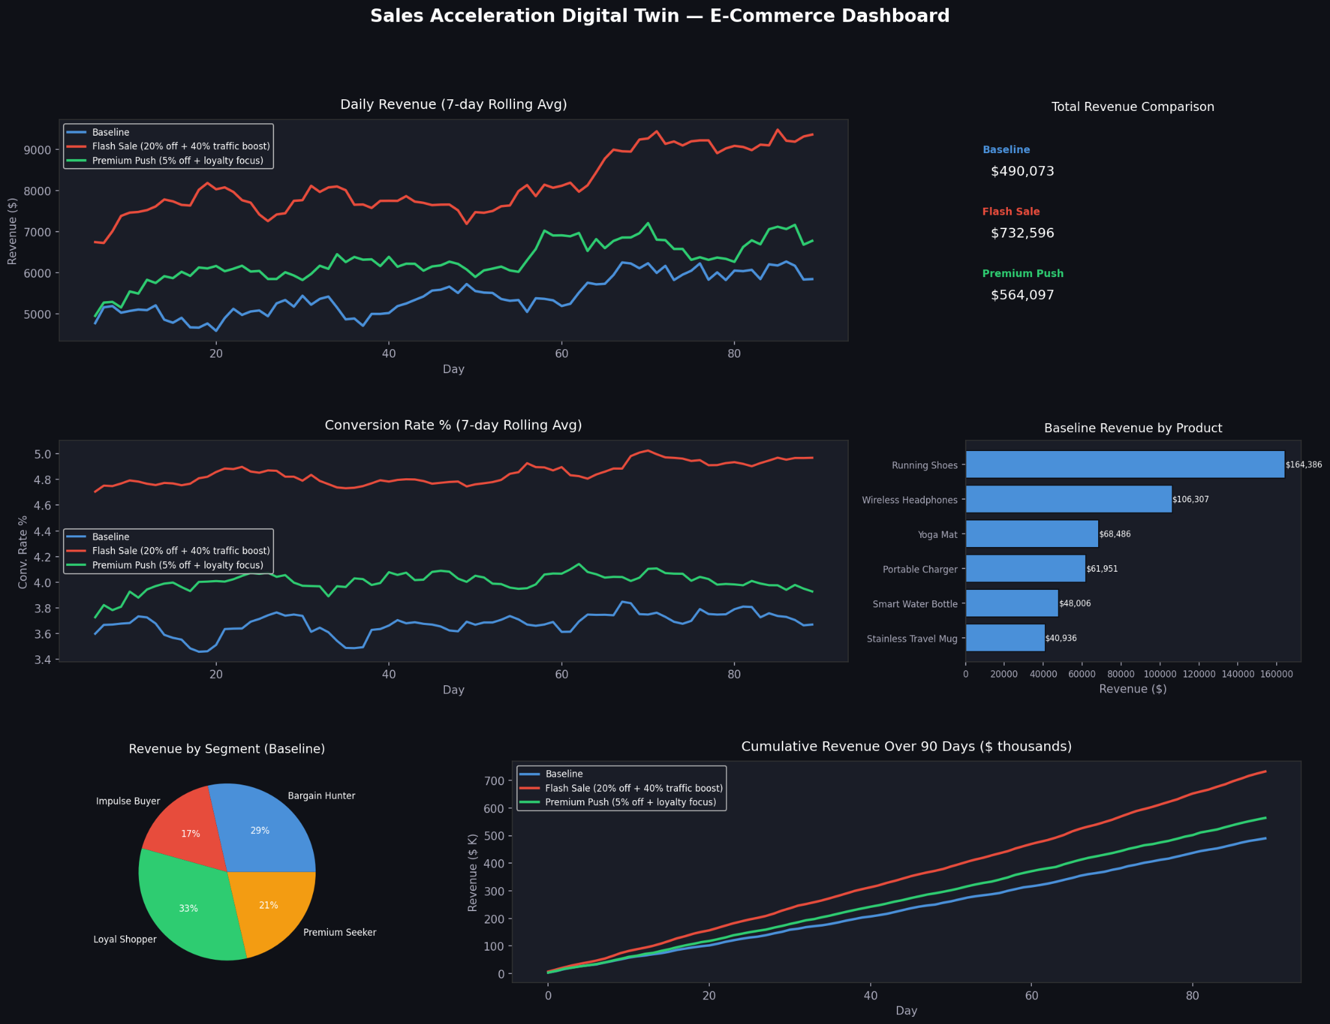

Conclusion :
This project demonstrates that a Digital Twin is a powerful tool for sales acceleration in e-commerce. By building a faithful virtual replica of a retail store's sales pipeline, businesses can test promotional strategies, pricing decisions, and inventory policies in a zero-risk environment — compressing weeks of real-world experimentation into minutes of simulation.
The 90-day simulation across three scenarios provided clear, quantifiable evidence that targeted promotional strategies (Flash Sale: +49.5%, Premium Push: +15.1%) significantly outperform baseline operations. The Digital Twin framework is production-ready and can be integrated with live data sources for real-time decision support.
Future work includes: multi-channel attribution modelling, A/B test simulation, and reinforcement learning-based scenario optimisation to automatically discover the highest-performing sales strategy.

